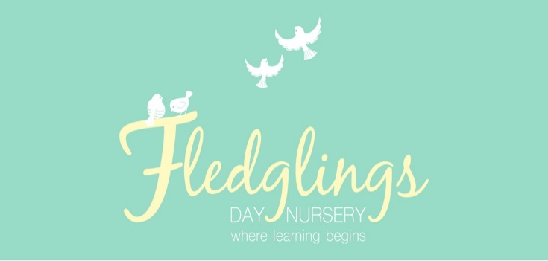

Welcome to the final summer term at Fledglings We’re looking forward to busy and fun few weeks in the sunshine!

We have a number of great things happening this half term including a our annual sponsored read and preschool graduation ceremony. Please see the diary dates below for more information.

Summer term 2

**Week commencing: 5th June 2023**

**Key Texts**

Our key texts this half term are as follows:

Tree room – ***Shark in the Park***

A lovely rhyming story exploring what we can see in our outdoor envionment

Sky Room – ***The Animal Boogie***

This is a sing a long story which will support children’s understanding of rhyme.

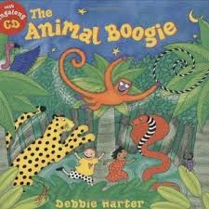

Please look out for a word mat to use with your child at home.

Children in the nest room will be learning the following nursery rhymes:

* *- 1,2,3,4,5 once I caught a fish alive*
* *- Row, row, row your boat*
* *- I had a little turtle*

And the book ‘’Under the Sea’

**Diary Dates**



**Sponsored Read – w/c: 12th July 2023** – Children will be invited to take part in a sponsored read and we will welcome a visit from our local Usbourne partner, Jayne, who will share stories with the children. Sponsor forms will be sent home after the holidays.

**Trip to Yorkshire Wildlife Park – 15th June 2023**

Our preschool children will be visiting the Yorkshire Wildlife Park and taking part in a classroom sessions ‘Aren’t Animals Amazing!’

**Stay & Play – Saturday 24th June 2023**

Please join us for our stay and play session. The focus this term is outdoor learning. There will be lots of fun actitivies to take part in alongside your child. Siblings and other family members are welcome.

**Summer Party Week – w/c: 17th July 2023** – Children will enjoy a range of party games and activities throughout the last week of the term, including a visit from the ice cream van!

**Preschool Graduation – 20th July 2023** – Parent and carers of children who are leaving for school in September 2023 will receive an invite to their child’s graduation ceremony and celebration.

**Summer holiday dates**: Friday 21st July 2023 – Monday 4th September 2023.

**Bank holiday** – **August 28th 2023** - The nursery will be closed for the August bank holiday.

**Fees and Funding**

From September 2022 there will an increase to our current fees as follows:

* **Full day - £44.00**
* **Half day - £26.00**
* There will be no increase to the cost of meals or the hourly rate.

If your child turns 3 before 31st August 2023 they may be eligible for 30 hours funding. Check your eligablility on -:**www.childcarechoices.gov.uk**

**Get in Touch!**

Find us on Facebook and Instagram: Fledglings Rossington

Visit our website: [www.fledglingsdaynursery.com](http://www.fledglingsdaynursery.com)

Email: info@fledglingsdaynursery.co.uk

Call us on: 01302 840925

**Drop off/pick up**

On arrival at nursery, please press the buzzer and a member of staff will speak to you through the intercom to awknowledge you. A staff member will then meet you at the door to collect/hand over your child.

During this initial settle in period we are welcoming parents and carers into the setting. If you would like to come into the setting please let a member of staff know.

**Please ensure that you wear a mask when you enter the building, unless you are exempt.**

**Nursery Fees**

Our nursery fees are as follows:

Full day – 38.00

Half day – 25.00

Hourly rate – 5.00 per hour

Meal fees apply for children taking up their free nursery entitlement (15 or 30 hours). Alternatively you are welcome to provide your child with a packed lunch.

Our meal fees are as follows:

Dinner – 2.00

Tea – 1.00

There is no charge for breakfast and snacks.

Invoices are sent out monthly via the famly app and payment details can be found on the invoice.

**Your Place**

Your place hubs are spaces where you can drop in and talk to one of the team about any issues you are facing. The team can help you with parenting support, benefits, or support you with returning to studying as well as many more things.

There are 4 Your Place Hubs across Doncaster - call, email or drop in, 8:30 am - 4:30 pm, Monday to Friday:

**North Hub** | Woodlands Library, Windmill Balk Lane, DN6 7SB | [01302 736787](tel:01302736787) | [LocalSolutionNorth@doncaster.gov.uk](mailto:LocalSolutionNorth@doncaster.gov.uk)   
**East Hub** | The Vermuyden Centre, Field Side, Thorne, DN8 1DA | [01302 736336](tel:01302736336) | [LocalSolutionEast@doncaster.gov.uk](mailto:LocalSolutionEast@doncaster.gov.uk)   
**South Hub** | Conisbrough Community Library, Old Road, DN12 3ND | [01302 736644](tel:01302736644) | [LocalSolutionSouth@doncaster.gov.uk](mailto:LocalSolutionSouth@doncaster.gov.uk)   
**Central Hub** | Civic Office, Waterdale, Doncaster, DN1 3BU | [01302 736409](tel:01302736409) | [LocalSolutionCentral@doncaster.gov.uk](mailto:LocalSolutionCentral@doncaster.gov.uk)



**Hatching chicks**

As part of their topic next half term, the preschool children will be hatching some chicks. Children across the nursery will have the opportunity to see the chicks as they hatch, providing a great learning opportunity.

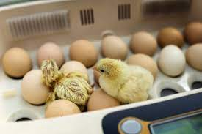

**Multicultural Week**

Our multicultural week last half term was a great success, thank you to everyone who contributed. Children had the opportunity to learn about different coutries and cultures and taste foods from around the world.

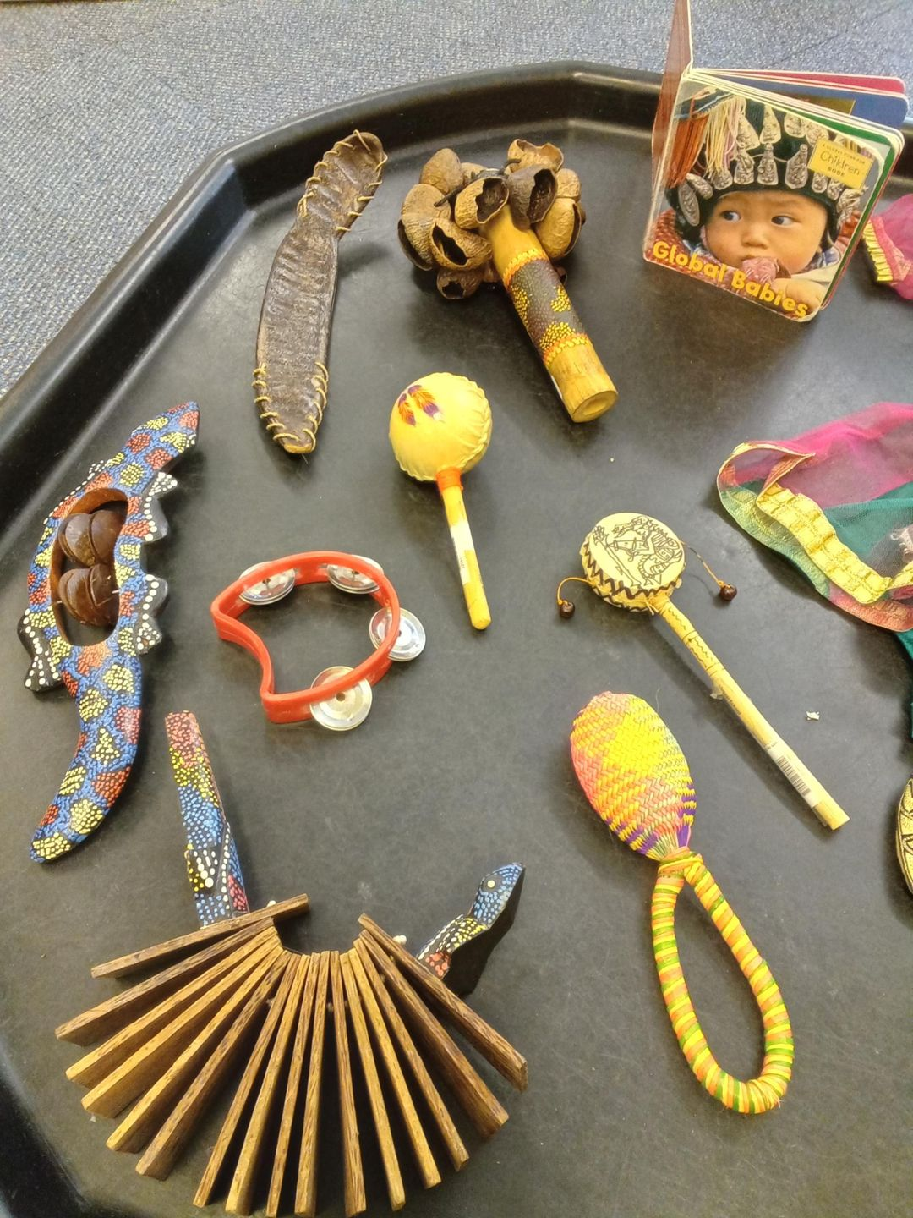

**Makaton**

At Fledglings we use a number of Makaton signs with all our children. Makaton is a visual way to develop communication skills, which helps stimulate sounds and words. The visual way of communicating stimulates language development. We will be sharing a Makaton sign of the week with you each week on Famly.

