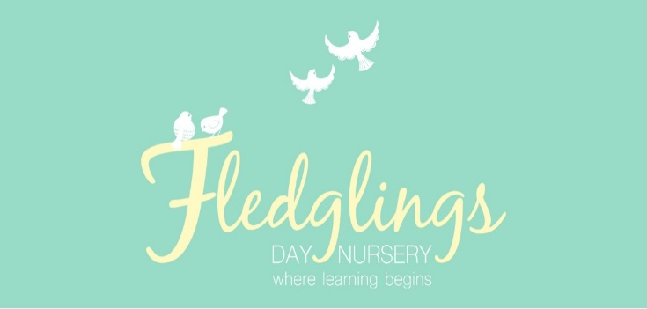

Welcome back to the summer term at Fledglings Day Nursery. I hope you all had a lovely Easter break.

We are looking forward to spending a lot of time in our outdoor areas as the weather improves.

We have the photographer visiting this half term as well as activities to celebrate King Charles’ coronation.

Please see the key dates for your diary below 😊

Summer term 1

**Week commencing:17th April 2023**

**Key Texts**

Our key texts this half term are as follows:

Tree room – ***Kitchen Disco***

This rhyming story introduces children to a wide variety of fruit.

Sky Room – ***Walking Through the Jungle***

This story about a little boy’s journey through the jungle introduces a variety of verbs such as ‘creeping’, ‘wading’ and ‘crawling’.

Please look out for a word mat to use with your child at home.

Children in the nest room will be learning the following nursery rhymes:

- Mary Mary Quite Contrary

- Mary Had a Little Lamb

**Diary Dates**

**1st May 2022 – Nursery CLOSED – May bank holiday**

**8th May 2022 – Nursery CLOSED – Coronation bank holiday**

**29th May – Nursery CLOSED – Bank Holiday**

**29th May – 2nd June 2023 – Half term Holidays**

**W/C 1st May 2023** The children will take part in activities relating to the King’s coronation throughout the week. **We will have a coronation picnic on Friday 5th May 2023.**

**11th May 2023** – Photo day! The photographer will be visiting the nursery from 9:30am. If your child is not due to attend you are weclome to bring them in for a photo. Further details to follow.

**W/C 15th May 2023** Wellbeing week

In recognition of the national mental health awareness week, children will take part in a range of activities to promotte their well being. More details to follow.

**Fundraising**

Thank you to everyone who took part in our Easter raffle, helping us to raise money for the nursery. We have put the money raised towards a new water table for the preschool garden!

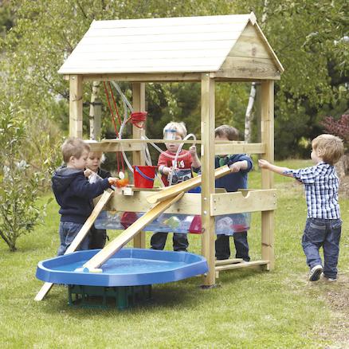

As the weather improves, please ensure your child brings a sunhat labelled with their name to nursery every time they attend.

We provide children’s factor 50 suncream to all children. If you would prefer to supply your own, please let a member of staff know.

**Get in Touch!**

Find us on Facebook and Instagram: Fledglings Day Nursery

Visit our website: [www.fledglingsdaynursery.com](http://www.fledglingsdaynursery.com)

Email: info@fledglingsdaynursery.co.uk

Call us on: 01302 840925

**Drop off/pick up**

On arrival at nursery, please press the buzzer and a member of staff will speak to you through the intercom to awknowledge you. A staff member will then meet you at the door to collect/hand over your child.

During this initial settle in period we are welcoming parents and carers into the setting. If you would like to come into the setting please let a member of staff know.

**Please ensure that you wear a mask when you enter the building, unless you are exempt.**

**Nursery Fees**

Our nursery fees are as follows:

Full day – 38.00

Half day – 25.00

Hourly rate – 5.00 per hour

Meal fees apply for children taking up their free nursery entitlement (15 or 30 hours). Alternatively you are welcome to provide your child with a packed lunch.

Our meal fees are as follows:

Dinner – 2.00

Tea – 1.00

There is no charge for breakfast and snacks.

Invoices are sent out monthly via the famly app and payment details can be found on the invoice.

**Healthy Lifestyles**

Did you know that once you child is one year old, feeding from a bottle should be discouraged? Drinking sweetened drinks from a bottle causes tooth decay in young children. Drinks flow very slowly through a teat which means that they are in contact with a child’s teeth for longer. Using an open cup or a free flow cup without a valve will help your baby learn how to sip and is better for their teeth. It might be messy at first but be patient!

For more information please visit: [Drinks and cups for babies and young children - NHS (www.nhs.uk)](https://www.nhs.uk/conditions/baby/weaning-and-feeding/drinks-and-cups-for-babies-and-young-children/)

