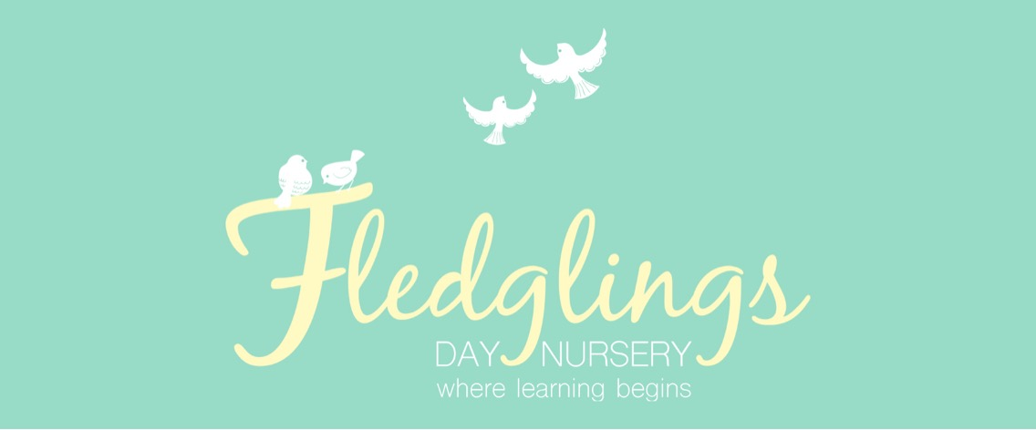
Welcome back to a new academic year at Fledglings Day Nursery. I hope you enjoyed a great summer and had the chance to relax and spend time with family & freinds.
We are delighted to be welcoming some new children to the setting this term as well as some familiar faces. We have a busy term ahead! Please see the dates below for more information.

Week commencing: 4th September 2023

Autumn term 1

Key dates

Term dates
The funding term starts on Monday 4th September 2023.
Half term is from Monday 23rd October to Friday 27th October 2023.

The funding term ends on Tuesday 19th December 2023.
The nursery will close at 5:30pm on Friday 22nd December 2023 and repopen on Tuesday 2nd January 2024.

African Ark Workshop
Friday 15th September 2023 – 10:00am and 3:00pm
Children in the sky room will take part in an African workshop. They will have the opportunity to crate Afrcian art and learn songs and dances.

Oral Health Week
w/c: 25th September 2023
Throughout oral health week children will take part in activities which promote good oral health. We will also send home advice and ideas to help you support your child’s oral health at home.

Key texts

Our key texts this half term are as follows:

Tree room – ‘Dear Zoo’
A lovely lift the flap story featuring zoo animals.


Sky Room – Giraffes can’t dance
The story of a lonely giraffe who learns that it’s okay to be different.



Please look out for a word mat to use with your child at home.

Children in the nest room will be learning the following nursery rhymes:
- Incy Wincy Spider
- Miss Polly had a dolly
- Twinkle Twinkle Little Star

Your child will be bringing home a sample Christmas card in the next few weeks and you will have the opportunity to order cards and other items printed with their design! 

Staff training day

On Saturday 2nd September 2023 the staff from our setting joined together with Fledglings Rossington to take part in a training day. The training included:
- Safeguarding updates
- The Stautory Framework for the Early Years Foundation Stage (2023)
- Planning provocations and invitation to play.

By investing in staff training such as this, we support staff to be able to provide the best possible care and education for your children.


We play outside whatever the weather so don’t forget to send your child with their wellies and a waterproof coat! Please label everything with your child’s name.

Get in Touch!
Find us on Facebook and Instagram: Fledglings Day Nursery
Visit our website: www.fledglingsdaynursery.com
Email: info@fledglingsdaynursery.co.uk
Call us on: 01302 840925

Our Staff

We said a fond farewell to Jojo at the end the end of the summer as she left to pursue different career options. We are delighted to be welcoming back Gemma Brewster this term following her maternity leave. We are excited to welcome a new member of staff to our nursery team. Laura Cunningham will be joining us as a Deputy Manger and will be based in the Sky Room. Laura is a level 6 practitioner with many years of experience in the early years.

Senior Leadership Team |   Sonya Gregory Nursery Manager, Designated Safeguarding Lead and SENDCo |   Chloe Smart  Deputy Manager, Depurty designated safeguarding lead and SENDCo
Nest Room |   Diane Lidley  Baby Room Lead  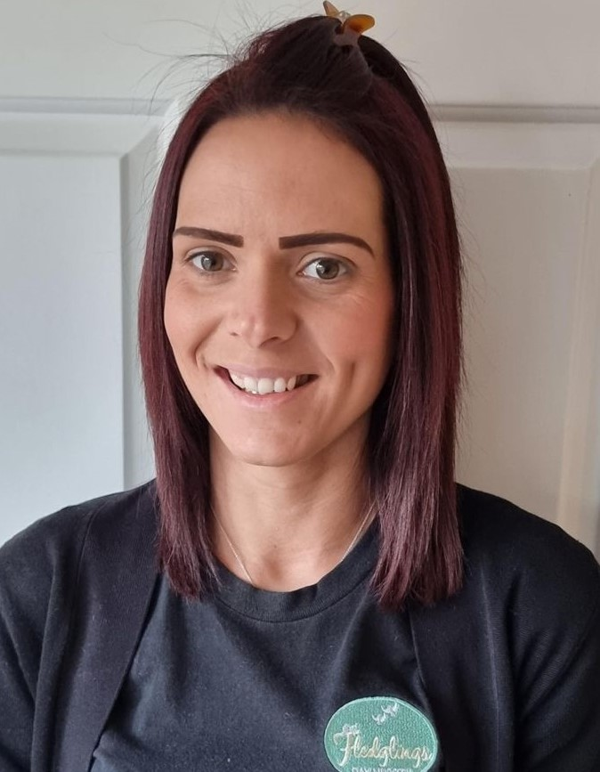  Jade Dougherty  Nursery Nurse    Magda Jelinska  Nursery Nurse |   Gemma Brewster  Nursery Nurse  Kaydie Petch  Apprentice Nursery Nurse  Millen-Mae Bowman  Nursery Nurse
Tree Room | 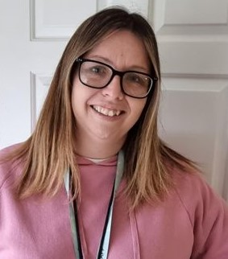  Rebecca Wriath  Toddler Room Lead  Danielle Arnold  Nursery Nurse | 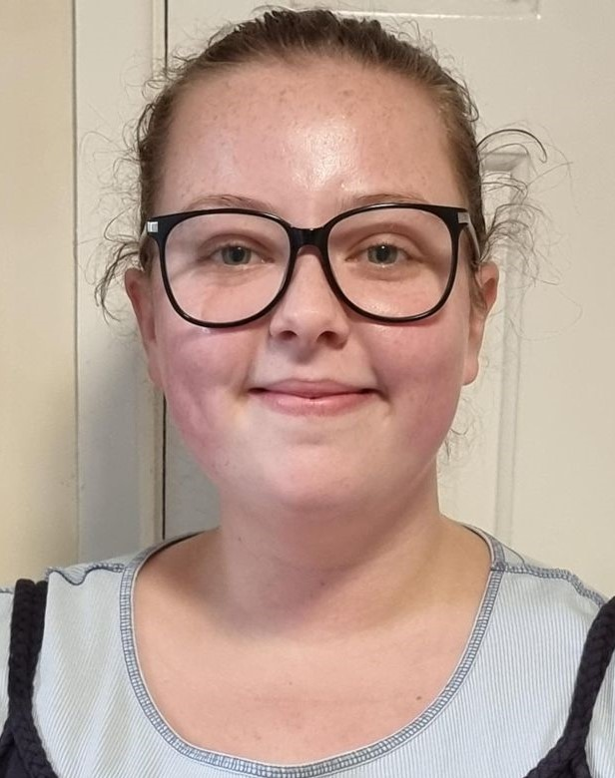Becky Corton  Nursery Nurse    Charlotte Wade  Nursery Nurse
Sky Room | Jade Poole  Preschool Room Lead  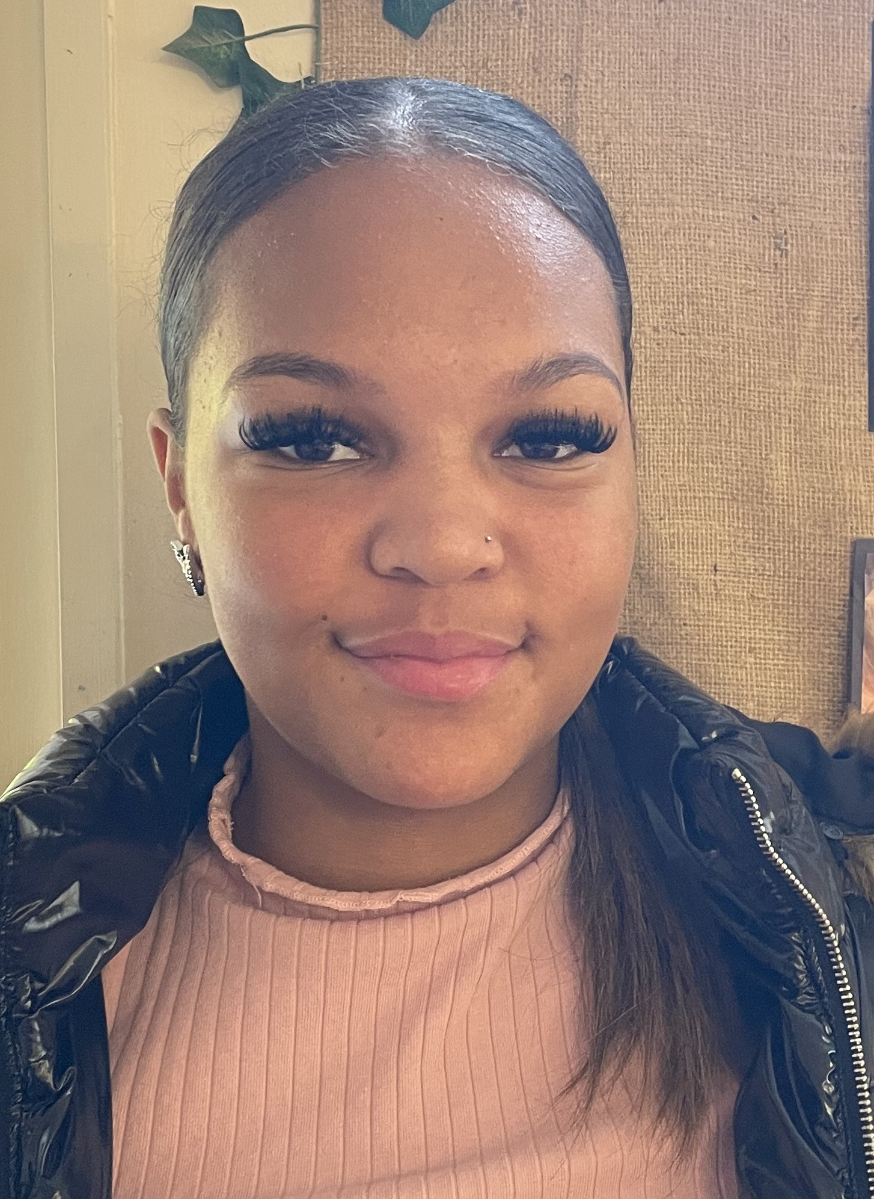Tyra Madzonga  Apprenctice Nursery Nurse | Joanna Hopson  Nursery Assistant (SEND support)

